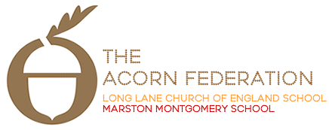

Garden Class Themes
Spring Term 2022

Art and Design
The children will be making a toy vehicle. They will be designing their own, following their design and then evaluating their finished product.
English
Our texts for this term are Robin Hood and Toy Story. The children will further develop their understanding of sentence structure and what a sentence needs. We will look at different word classes and apply this learning to make our sentences exciting. We will learn new vocabulary and develop our comprehension skills by re-reading and learning our chosen text orally.

RE
The children will look at What Muslims believe and Why Easter matters to Christians.

PSHE
Over the course of the term the focus will be changes and being me. The children will explore the lifecycle of an animal and humans. They will look at strategies to manage when finding changes difficult. The second part of the term will be focused on looking at how people are the same and different. They will explore what makes people special and unique.
Mathematics
In year one the children will be looking at addition and subtraction and comparing number sentences. They will start to cross 10.
Year 2 will be making equal groups, using arrays and looking at facts related to the 2, 5 and 10 times tables.

Music
The children will be focusing on the Groove (Different Styles) and Round and Round (Bossa Nova). They will be listening to music and discussing different genres.

Computing
The children will look at digital writing and start to make presentations.

PE
The children will be starting to play team games. They will then move on to yoga in the second half of the term.

History
The children will learn Henry V111 and changes in toys over time.
Geography
The children will learn about the United Kingdom. They will recognise the difference between a town and country locations. They will look at physical features of England and its capital city and also features of Northern Ireland, Scotland and Wales.

