Marston Montgomery Primary School
Where children learn for life!
 |  | Small class sizes
 |  | Breakfast & After School clubs
 |  | Dedicated and friendly staff
 |  | Forest School
 |  | Free-flow access to outdoor learning area for Reception children
Please ring school to book an appointment to look round
Will your child be starting school in September 2021?
Do you want a small, welcoming school where your child will be nurtured so that they achieve and flourish?
You are invited to join us for a tour of our school and an informal chat with staff.
Come and see our school in action and hear about life at Marston.
Ofsted Parent View 2019/20 results – 100% of parents completing the questionnaire would recommend the school to another parent.
In year applications also welcome.

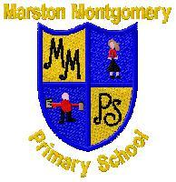 | Marston Montgomery  Primary School  Thurvaston Road  Marston Montgomery  Ashbourne  DE6 2FF  01889 590373  info@marstonmontgomery.  derbyshire.sch.uk

