Marston Tots at
Marston Montgomery Primary School
Thurvaston Road, Marston Montgomery, Ashbourne DE6 2FF
Please join our friendly group for a morning of playing, chatting and coffee. We look forward to meeting you. Our Tots group meets from 9:15am until 11:15am. | 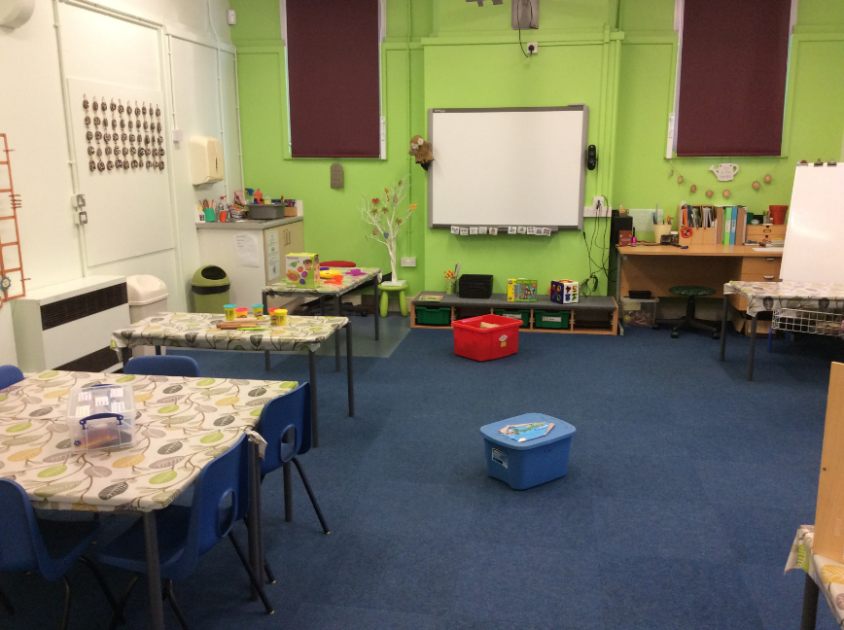

Sept | October | November |  |  | December |  | January | February
06/09/19 | 04/10/19 | 08/11/19 |  |  | 06/12/19 |  | 10/01/20 | 07/02/20
13/09/19 | 11/10/19 | 15/11/19 |  |  | 13/12/19 |  | 17/01/20 | 14/02/20
20/09/19 |  | 22/11/19 |  |  |  |  | 24/01/20
 |  | 29/11/19 |  |  |  |  | 31/01/20
March | April | May |  |  | June |  | July
06/03/20 | 03/04/20 |  | 01/05/20 | 05/06/20 |  | 03/07/20
13/03/20 | 24/04/20 |  | 08/05/20 | 12/06/20 |  | 10/07/20
20/03/20 |  |  | 15/05/20 | 19/06/20

You are also invited to join us on 17/06/20 for our Sports Day at Marston Montgomery (1:15pm – 3:30pm)
Call 01889 590373 for more information

